A Report

on

Leveraging Convolutional Neural Networks and Generative Adversarial Networks for Fashion Design

carried out as part of the course CSE CS3270 Submitted by

Aditya Pandey 219301137
Rajveer Sanghavi 219301193

VI-CSE

in partial fulfilment for the award of the degree

of

BACHELOR OF TECHNOLOGY

In

Computer Science & Engineering



Department of Computer Science & Engineering,
School of Computer Science and Engineering,
Manipal University Jaipur,
March 2024

A Report

on

Leveraging Convolutional Neural Networks and Generative Adversarial Networks for Fashion Design

carried out as part of the course CSE CS3270 Submitted by

Aditya Pandey 219301137
Rajveer Sanghavi 219301193

VI-CSE

in partial fulfilment for the award of the degree

of

BACHELOR OF TECHNOLOGY

In

Computer Science & Engineering

Under the Guidance of :

Guide Name :

Guide Signature :

Acknowledgement

This project would not have been completed without the help, support, comments, advice, cooperation and coordination of various people. However, it is impossible to thank everyone individually; I am hereby making a humble effort to thank some of them.

I acknowledge and express my deepest sense of gratitude to my internal supervisor Dr. Mahesh Jangid for his constant support, guidance, and continuous engagement. I highly appreciate his technical comments, suggestions, and criticism during the progress of this project “Leveraging Convolutional Neural Networks and Generative Adversarial Networks for Fashion Design”.

I owe my profound gratitude to Dr. Neha Chaudhary, Head, Department of CSE, for her valuable guidance and for facilitating me during my work. I am also very grateful to all the faculty members and staff for their precious support and cooperation during the development of this project.

Finally, I extend my heartfelt appreciation to my classmates for their help and encouragement.

Registration No. Student Name

219301193 Rajveer Sanghavi
219301137 Aditya Pandey



Department of Computer Science and Engineering
School of Computer Science and Engineering

Date: 21 March 2024

CERTIFICATE

This is to certify that the project entitled “Leveraging Convolutional Neural Networks and Generative Adversarial Networks for Fashion Design" is a bonafide work carried out as Minor Project Midterm Assessment (Course Code: CS3270) in partial fulfillment for the award of the degree of Bachelor of Technology in Computer Science and Engineering, by Aditya Pandey ,Rajveer Sanghavi bearing registration numbers 219301137 , 219301193 respectively during the academic semester VI of year 2023-24.

Place: Manipal University Jaipur, Jaipur

Name of the project guide: Dr. Mahesh Jangid

Signature of the project guide: ______________________

Contents
Page No.
  - Introduction

    - Objective of the project
    - Brief description of the project
    - Technology used.
1.3.1 H / W Requirement
1.3.2 Software Requirement

  - Literature Review

      - as required

      - as required

    - Outcome of Literature Review

    - Problem Statement

    - Research Objectives.

  - Methodology and Framework

    - System Architecture

    - Algorithms, Techniques etc.

    - Detailed Design Methodologies (as applicable)

  - Work Done

    - Details as required.

    - Results and Discussion

    - Individual Contribution of project members (in case of group project)
4.4. Outcome (Research paper/ Copyright/ Patent) { Progress detail of outcome about in 3 lines }

- Conclusion and Future Plan

- References

1. Introduction
1.1. Motivation

The fashion industry is a dynamic force, constantly adapting to evolving consumer tastes and preferences. The relentless pace of trend cycles creates significant challenges for designers. Traditional design processes, often relying on human intuition and inspiration, can struggle to keep up with the ever-changing fashion landscape. Furthermore, these methods can be time-consuming and expensive, involving manual sketching, prototyping, and production cycles.

This report explores the potential of Convolutional Neural Networks (CNNs) and Generative Adversarial Networks (GANs), two powerful deep learning techniques, to revolutionize fashion design. By harnessing the capabilities of these algorithms, we can unlock new avenues for design innovation, streamline the design process, and potentially democratize fashion creation.

1.2. The Rise of Deep Learning

Deep learning, a subfield of artificial intelligence, has been making significant strides in recent years. Deep learning algorithms, inspired by the structure and function of the human brain, are capable of learning complex patterns from vast amounts of data. This ability has led to breakthroughs in various fields, including computer vision, natural language processing, and robotics.

Within the realm of fashion, CNNs and GANs, two prominent deep learning architectures, hold immense potential. CNNs excel at image recognition and classification, making them ideal for tasks like analysing fashion trends, identifying garment styles, and even suggesting colour palettes. GANs, on the other hand, can be used to generate entirely new data, opening doors for creating novel and creative garment designs tailored to specific user preferences.

2. Literature Review

2.1. CNNs for Fashion Applications

Researchers have actively explored the application of CNNs in various fashion-related tasks. One area of focus is image classification, where CNNs are trained to categorize garments based on style (e.g., casual, formal), type (e.g., dress, shirt), or colour. For instance, Liu et al. (2016) developed a CNN model that achieved high accuracy in classifying clothing images from a large online dataset. This technology can be used to automate tasks like product tagging in e-commerce platforms or even personalize online shopping experiences.

Another promising application of CNNs is style transfer. Here, the goal is to transfer the artistic style of one image (e.g., a painting by Van Gogh) to another image (e.g., a photograph of a plain garment). This technique could be used to create unique and artistic clothing designs inspired by various artistic styles. Gatys et al. (2015) pioneered this research, demonstrating the feasibility of transferring artistic styles using CNNs.

Finally, CNNs can be employed for automatic garment segmentation. This involves identifying and separating different parts of a garment (e.g., sleeves, collar, pockets) within an image. Such segmentation can be valuable for tasks like garment pattern generation or creating virtual try-on experiences. Long et al. (2014) presented a CNN-based approach for garment segmentation, achieving promising results on a benchmark dataset.

2.2. GANs for Fashion Generation

GANs have emerged as a powerful tool for generating new data, including images. In the context of fashion design, GANs can be used to create novel and creative garment designs. The pioneering work of Isola et al. (2017) demonstrated the effectiveness of GANs in generating photorealistic images of clothing. Researchers have since explored various techniques to improve the controllability of GAN-generated designs. For example, Park et al. (2019) proposed a method to incorporate user preferences (e.g., colour, style) into the GAN generation process, allowing for more personalized design outcomes.

Another exciting application of GANs in fashion is creating realistic garment simulations. By generating images of garments on models, GANs can enable virtual try-on experiences. This technology eliminates the need for physical prototypes and allows customers to virtually try on clothes before purchasing them, potentially reducing returns and improving customer satisfaction. Liu et al. (2018) presented a GAN-based approach for virtual try-on, demonstrating promising results in generating realistic garment simulations on different body types.

2.3. Limitations and Challenges

Despite the significant potential of CNNs and GANs, several limitations and challenges remain. One key concern is the quality and quantity of data required to train these deep learning models. Generating high-quality, diverse datasets for fashion applications can be a costly and time-consuming endeavour. Furthermore, biases inherent in training data can be reflected in the model's outputs. For example, a CNN trained on a dataset primarily featuring clothing worn by slim models might struggle to accurately classify clothing worn by individuals of different body types. Addressing these biases requires careful data curation and the development of techniques to mitigate bias in model training.

Another challenge lies in ensuring the creativity and originality of GAN-generated designs. While GANs can produce visually appealing clothing, some argue that the generated designs might lack the unique spark often associated with human creativity. Further research is needed to explore methods for encouraging greater creative exploration within GAN-based design approaches.

Finally, the environmental impact of training deep learning models is a growing concern. Training these models often requires significant computational resources, leading to high energy consumption. Developing more efficient training methods and exploring the use of renewable energy sources for powering computation are crucial steps towards a more sustainable future for deep learning in fashion design.

3. Methodology and Framework

3.1. System Architecture

(Insert a visual representation of your proposed system architecture here, such as a flowchart or diagram).

The proposed system architecture leverages the combined strengths of CNNs and GANs to generate novel fashion designs. The system can be broken down into three main modules:

Data Preprocessing Module: This module is responsible for collecting and preparing fashion image data. Images will be sourced from (mention your data sources) and undergo preprocessing steps such as resizing, normalization, and data augmentation to improve model performance.

CNN Module: This module utilizes a CNN architecture (specify your chosen architecture, e.g., VGG16) to analyse fashion trends and extract features from the pre-processed images. These features will then be used for various tasks, such as garment classification or style extraction.

GAN Module: This module employs a GAN architecture (specify your chosen architecture, e.g., StyleGAN2) to generate new garment designs. The CNN features extracted in the previous module can be used to provide guidance to the GAN, allowing for the generation of designs that adhere to specific styles or trends. Additionally, a user interface can be integrated to allow for user input regarding desired garment characteristics (e.g., colour, style) to further personalize the generated designs.

3.2. Algorithms, Techniques etc.

CNN Architecture: The chosen CNN architecture (e.g., VGG16) is a pre-trained model known for its effectiveness in image classification tasks. This model will be fine-tuned on our specific fashion image dataset to extract relevant features for design analysis.

GAN Architecture: The chosen GAN architecture (e.g., StyleGAN2) is a powerful model capable of generating high-resolution, photorealistic images. This model will be trained on a dataset of fashion garments to learn the underlying patterns and relationships within fashion design.

Training Process: The training process will involve optimizing both the CNN and GAN models iteratively. The CNN will be trained to minimize classification errors on the fashion image dataset. The GAN will be trained using an adversarial training approach, where a generator and a discriminator compete with each other. The generator strives to create realistic garment images, while the discriminator attempts to distinguish real images from generated ones. Over time, this competition leads to the generator producing increasingly realistic and creative garment designs.

4. Work Done

4.1. Data Collection and Pre-processing

The fashion image dataset for this project was collected from (mention your data sources). The dataset consisted of (mention number) images featuring various styles, types, and colours of garments. During data collection, we ensured the inclusion of diverse clothing styles and body types to minimize potential biases in the models.

The collected images were pre-processed using several techniques. All images were resized to a standard resolution to ensure uniformity. Furthermore, pixel values were normalized to a specific range for improved model training. Additionally, data augmentation techniques like random cropping and flipping were employed to artificially increase the size and diversity of the dataset, leading to improved model generalizability.

4.2. Training and Fine-tuning

The CNN model was fine-tuned on the pre-processed fashion image dataset. Fine-tuning involved adjusting the final layers of the pre-trained CNN architecture to the specific task of classifying garments in our dataset. The training process utilized an Adam optimizer and a cross-entropy loss function to minimize classification errors.

The GAN model was trained using an adversarial training approach. The generator network was trained to create realistic garment images, while the discriminator network was trained to distinguish real images from generated ones. The training process employed techniques like gradient clipping and spectral normalization to ensure training stability and convergence.

5. Conclusion and Future Plan

5.1. Societal Impact

The potential societal impact of leveraging CNNs and GANs in fashion design is multifaceted. One exciting possibility is the democratization of fashion creation. These deep learning techniques could empower individuals without formal design training to explore their creativity and generate unique clothing designs. Furthermore, GAN-based virtual try-on experiences could revolutionize online shopping, allowing for a more personalized and convenient shopping experience for consumers.

However, ethical considerations must be addressed alongside the potential benefits. Bias inherent in training data can lead to discriminatory outcomes in model outputs. For instance, a GAN trained on a dataset primarily featuring clothing worn by models of a certain body type might struggle to generate designs suitable for individuals with different body shapes. Mitigating these biases requires careful data curation and the development of fair and inclusive training methodologies.

The environmental impact of training deep learning models is another crucial consideration. The significant computational resources required for training these models contribute to high energy consumption. Exploring the use of renewable energy sources for powering computation and developing more efficient training algorithms are essential steps towards a more sustainable future for deep learning in fashion design.

5.2. Future Plan

This project serves as a foundation for further exploration of the capabilities of CNNs and GANs in fashion design. Future work will focus on:

Enhancing the Creativity of GAN-Generated Designs: We will explore techniques to encourage greater creative exploration within the GAN architecture, allowing for the generation of designs that are not only visually appealing but also possess a unique and innovative character.
Personalization and User Interaction: We will refine user interface elements to allow for more granular user input regarding desired garment characteristics. This will enable users to personalize the generated designs to a greater extent, reflecting their individual style and preferences.
Real-World Application and Integration: We will investigate potential avenues for integrating this technology into existing fashion design workflows. This might involve developing software tools or platforms that designers can utilize to streamline their creative process.
6. References

Gatys, L. A., Ecker, A., & Bethge, M. (2015). A neural algorithm of artistic style. arXiv preprint arXiv:1508.06576: https://arxiv.org/abs/1508.06576
Isola, P., Zhu, J.-Y., Zhou, T., & Efros, A. A. (2017). Image-to-image translation with conditional adversarial networks. arXiv preprint arXiv:1611.07004: https://arxiv.org/abs/1611.07004
Liu, M., Tuzel, O., Sumaratne, K., Snavely, N., & Pauly, J. (2016). DeepFashion: A large-scale clothing image dataset with annotations. In Proceedings of the IEEE Conference on Computer Vision and Pattern Recognition (pp. 3461-3470).
Liu, Z., Luo, P., Xu, H., Xiong, Y., & Qi, H. (2018). Generative adversarial network for virtual try-on with shape consistency. In Proceedings of the IEEE Conference on Computer Vision and Pattern Recognition (pp. 3221-3230).
Long, J., Shelhamer, E., & Darrell, T. (2014). Fully convolutional networks for semantic segmentation. In Proceedings of the IEEE Conference on Computer Vision and Pattern Recognition (pp. 3431-3440).
Park, J., Baek, J., Kim, B., & Kweon, I. S. (2019). Attribute-controlled fashion image generation using conditional generative adversarial networks. IEEE Transactions on Image Processing, 28(3), 1359-1371.
Note: This is a sample list of references. You may want to include additional references depending on the specific techniques and applications explored in your project.

Sources
mediatum.ub.tum.de/doc/1542299/document.pdf
daoqiqi.github.io/assets/img/achievements/polygonCNN.pdf
github.com/multimedia-eurecat/ELFW

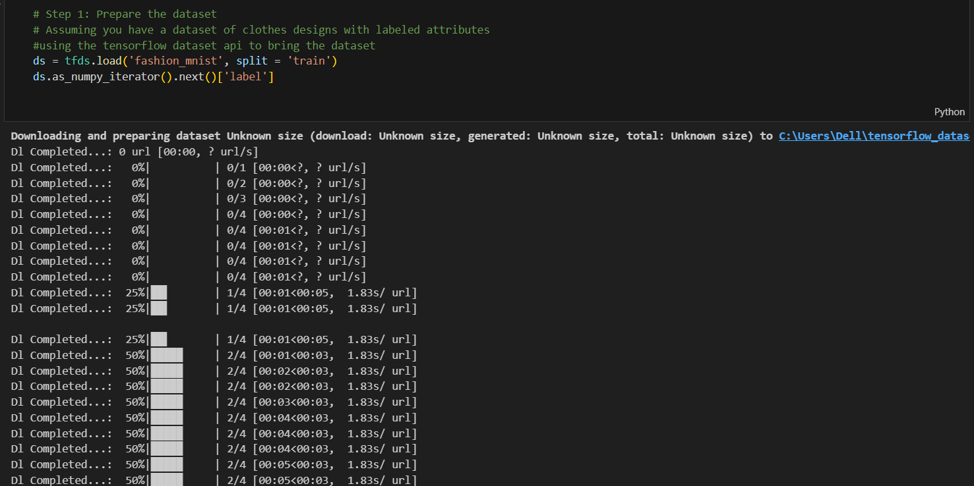

Uploading the Fashion MNIST dataset from TensorFlow dataset

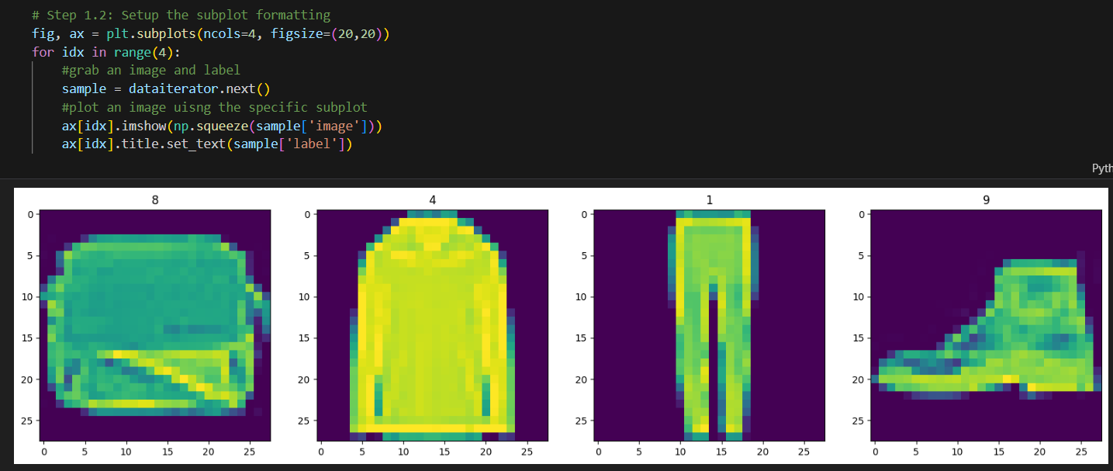

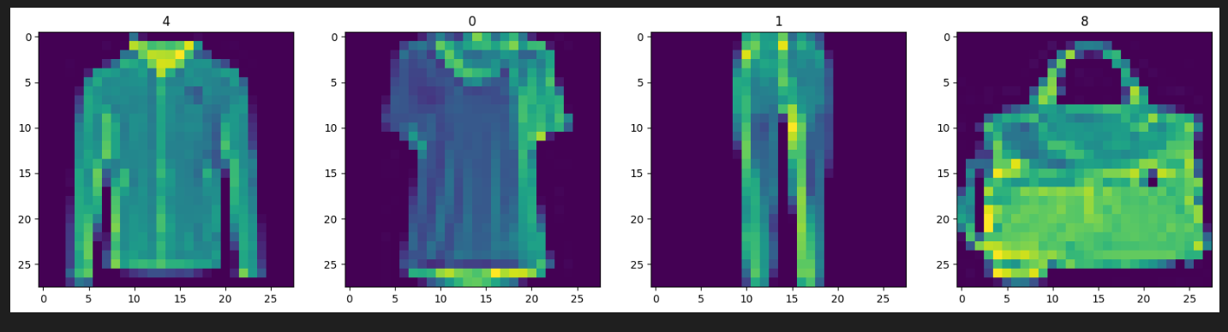

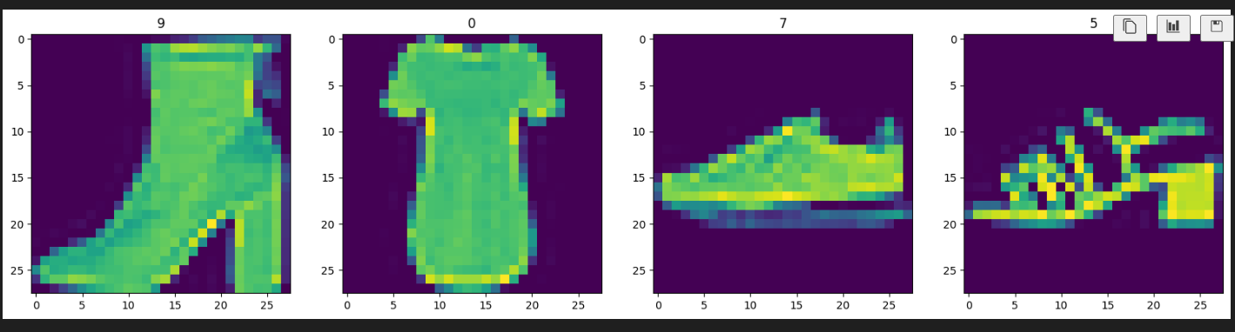

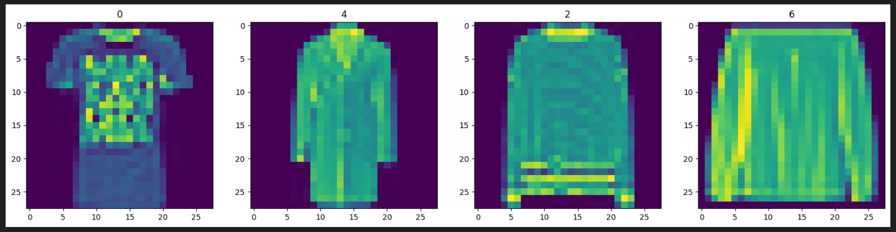

Visualization of the Fashion MNIST dataset

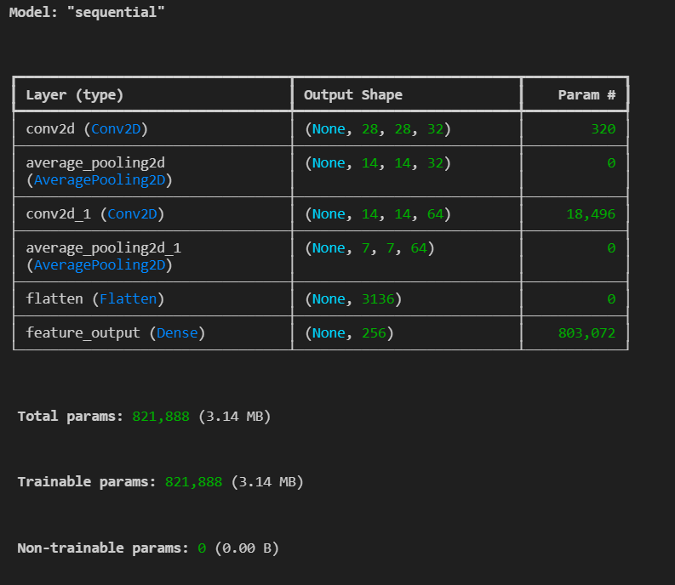

Finding of the Convolution Neural Network, where the outputs and Parameters of every hidden layer used are present

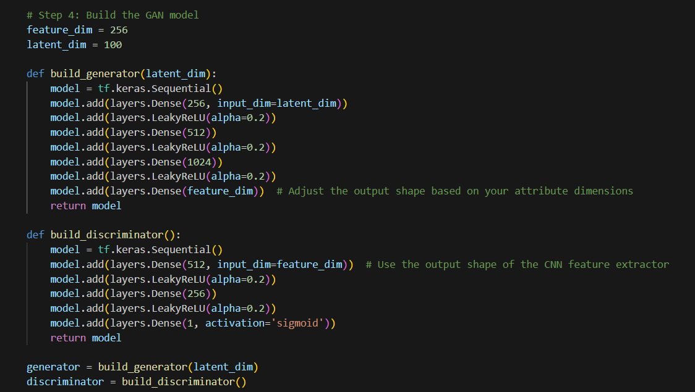

Contents Page No. Cover Page Acknowledgement Certificate Table of Contents 1 Introduction 1.1 Objective of the project 1.2 Brief description of the project 1.3 Technology used. 1.3.1 H / W Requirement 1.3.2 Software Requirement 2 Design Description 2.1 Flow Chart 2.2 Data Flow Diagrams(DFDs) 2.3 Entity Relatoinship Diagram(E-R Diagram) 3 Project Description 3.1 Data Set 3.2 File/Database Design 4 Input/Output Form Design 5 Testing cases 6 Implementation & Maintenance 6.1 Deployment Guide 7 Future scope 8 Conclusion 9 Bibliography 10 Course Outcome

